Primer Parcial
JUAN DAVID CARVAJAL CUCUÑAME, jdcarvajal@unicauca.edu.co

Entradas:
- Chicles:
Va a ser de 2 bits
C1 C2

100 pesos => 0 1
200 pesos => 1 0
500 pesos => 1 1
- Monedas:
Va a ser de 2 bits
C1 C2
100 pesos => 0 1
200 pesos => 1 0
500 pesos => 1 1

Salidas:
- Proporcionar chicle
S = 1 cuando si se entrega chicle

S = 0 cuando no se entrega chicle

- Devolución de moneda
C1 C2
100 pesos => 0 1
200 pesos => 1 0
500 pesos => 1 1

C1 | C2 | M1 | M2 | S | D1 | D2
0 | 0 | 0 | 0 | 0 | 0 | 0
0 | 0 | 0 | 1 | 1 | 0 | 0
0 | 0 | 1 | 0 | 1 | 0 | 1
0 | 0 | 1 | 1 | 0 | 1 | 1
0 | 1 | 0 | 0 | 0 | 0 | 0
0 | 1 | 0 | 1 | 0 | 0 | 1
0 | 1 | 1 | 0 | 1 | 0 | 0
0 | 1 | 1 | 1 | 0 | 1 | 1
1 | 0 | 0 | 0 | 0 | 0 | 0
1 | 0 | 0 | 1 | 0 | 0 | 1
1 | 0 | 1 | 0 | 0 | 1 | 0
1 | 0 | 1 | 1 | 1 | 1 | 0
1 | 1 | 0 | 0 | 0 | 0 | 0
1 | 1 | 0 | 1 | 0 | 0 | 1
1 | 1 | 1 | 0 | 0 | 1 | 0
1 | 1 | 1 | 1 | 1 | 0 | 0

Mapas de Karnaugh:

M1 M2  C1 C2 | 00 | 01 | 11 | 10
00 |  | 1 |  | 1
01 |  |  |  | 1
11 |  |  | 1
10 |  |  | 1

$$S=C1^{'}C2^{'}M1^{'}M2 + C1^{'}M1M2^{'} + C1M1M2$$

M1 M2  C1 C2 | 00 | 01 | 11 | 10
00 |  |  | 1
01 |  |  | 1
11 |  |  |  | 1
10 |  |  | 1 | 1

$$D1=C1^{'}M1M2 + C1C2^{'}M1 + C1M1M2'$$

M1 M2  C1 C2 | 00 | 01 | 11 | 10
00 |  |  | 1 | 1
01 |  | 1 | 1
11 |  | 1
10 |  | 1

$$D2=C1^{'}C2^{'}M1 + C1^{'}C2M2 + C1M1^{'}M2$$

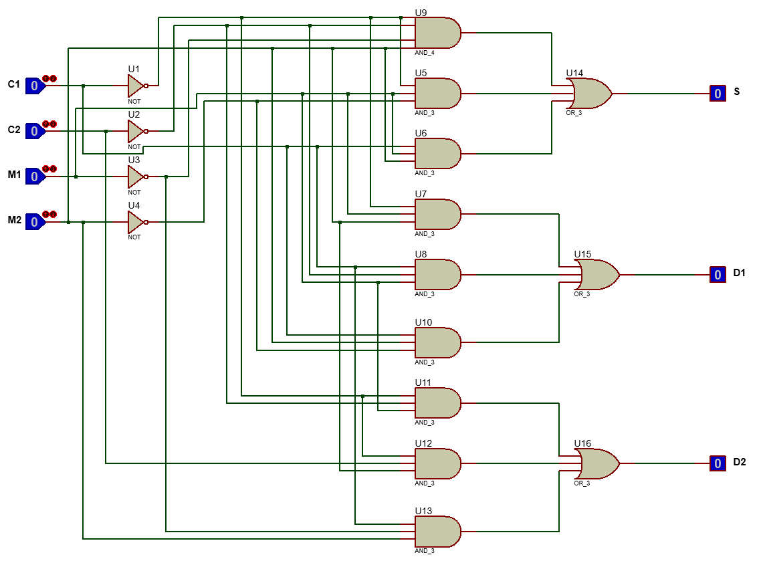

Entradas:

N

Teclado para los números: Para que sea el numero 4
E1 | E2 | E3 | E4 | E5 | E6 | E7 | E8
0 | 0 | 1 | 1 | 0 | 1 | 0 | 0

L

Teclado para los números: Para que sea la letra a
E9 | E10 | E11 | E12 | E13 | E14 | E15 | E16
0 | 1 | 1 | 0 | 0 | 0 | 0 | 1

Salidas:
A = números

B = Letras

E1 | E2 | E3 | E4 | E5 | E6 | E7 | E8
0 | 0 | 1 | 1 | 0 | 1 | 0 | 0

N1 | N2 | N3 | M | B | A
0 | 0 | 0 | 0 | 0 | 0
0 | 0 | 0 | 1 | 1 | 0
0 | 0 | 1 | 0 | 1 | 0
0 | 0 | 1 | 1 | 1 | 0
0 | 1 | 0 | 0 | 0 | 0
0 | 1 | 0 | 1 | 0 | 0
0 | 1 | 1 | 0 | 1 | 0
0 | 1 | 1 | 1 | 0 | 0
1 | 0 | 0 | 0 | 0 | 0
1 | 0 | 0 | 1 | 1 | 1
1 | 0 | 1 | 0 | 1 | 0
1 | 0 | 1 | 1 | 1 | 1
1 | 1 | 0 | 0 | X | X
1 | 1 | 0 | 1 | X | X
1 | 1 | 1 | 0 | X | X
1 | 1 | 1 | 1 | X | X

Mapas de Karnaugh:

N3 M  N1 N2 | 00 | 01 | 11 | 10
00 |  | 1 | 1 | 1
01 |  |  |  | 1
11 | X | X | X | X
10 |  | 1 | 1 | 1

$$B= N2^{'}M + N3M'$$

N3 M  N1 N2 | 00 | 01 | 11 | 10
00
01
11 | X | X | X | X
10 |  | 1 | 1

$$A=N1M$$

